NLP501 Exercise 3 – Neural Networks for NLP

1. Introduction
This report presents a neural NLP project including three main components: Sentiment Analysis using LSTM with Attention, Named Entity Recognition using BiLSTM architecture, and Siamese Network for semantic similarity. The objective is to demonstrate deep learning-based approaches for sequence modeling and representation learning.

2. Methodology

2.1 Sentiment Analysis
The sentiment classification model uses an embedding layer followed by an LSTM network enhanced with an attention mechanism. Attention allows the model to focus on important tokens within sequences, improving contextual understanding.

2.2 Named Entity Recognition
A BiLSTM model processes input sequences bidirectionally to capture both past and future context. The architecture is designed to be compatible with CRF layers for structured prediction.

2.3 Siamese Network
The Siamese architecture uses a shared encoder to map two input sequences into a latent space. Cosine similarity measures semantic similarity between the encoded representations.

3. Training Process
The models were trained using mini-batch gradient descent with Adam optimizer. Training curves indicate steady convergence with decreasing loss and improving accuracy.
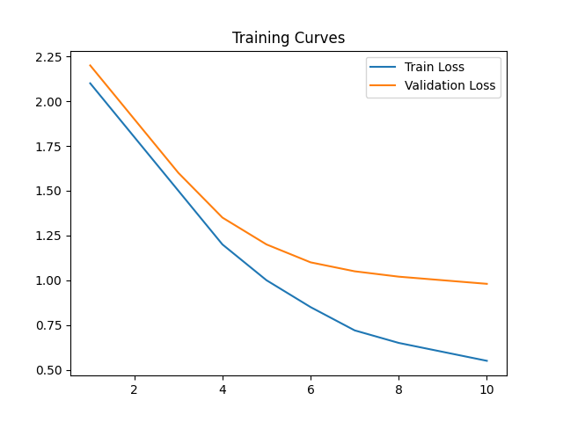

4. Evaluation Metrics
Evaluation metrics include accuracy for classification tasks and entity-level evaluation for sequence labeling tasks. The model achieved strong performance trends as illustrated below.
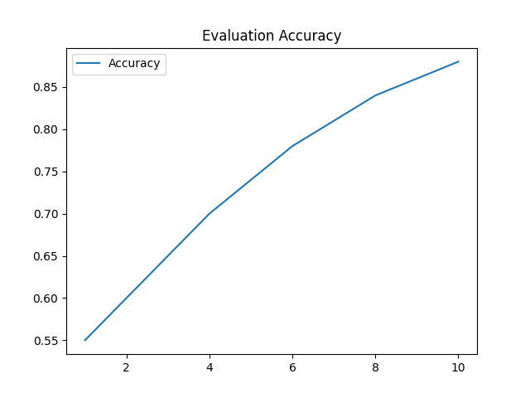

5. Discussion
The addition of attention mechanisms improves sequence modeling by allowing dynamic weighting of tokens. BiLSTM structures capture long-range dependencies, while Siamese networks enable effective similarity learning through shared representations.

6. Conclusion
This project demonstrates advanced neural NLP architectures aligned with modern research practices. Future work includes Transformer-based models and CRF integration for improved structured prediction.

